Q1: - Implement Factory pattern for creating pages and popups (Modals, Alerts, etc.) in website for pages separate interface defined and for popups separate interface defined.

Code:-

Main:-

WebFactory obj_web = new WebFactory();

PopUpFactory obj_pop = new PopUpFactory();

Console.WriteLine("What do you want to visit :\n1)Website:\n2)Popups:");

String opt0 = Console.ReadLine();

if (opt0 == "1")

{

obj_web.getWeb();

}

else if (opt0 == "2")

{

Console.WriteLine("Enter option: \n1)Alerts: \n2)Modal:");

String opt1 = Console.ReadLine();

obj_pop.factory(opt1);

}

else

{

Console.WriteLine("Inavalid Input.\nTry Again");

}

Classes:-

Alert:-

class Alert:InterfacePopups

{

public void message()

{

Console.WriteLine("Warning: This is Alert");

}

}

Home:-

class Home:InterfaceWebsite

{

public string WebSiteName

{

get { return "WebFactory"; }

}

public void Web_Home()

{

Console.WriteLine("This is Home Page.");

Console.WriteLine("You are on Home Page");

}

}

Contact:-

class Contact:InterfaceWebsite

{

public string WebSiteName

{

get { return "WebFactory"; }

}

public void Contactus()

{

Console.WriteLine("This is a Contact us page");

Console.WriteLine("Good Bye...");

}

}

Intrerface-Popup:-

class InterfacePopups

{

//void message();

internal void factory(string opt1)

{

throw new NotImplementedException();

}

}

Interface-Website:-

interface InterfaceWebsite

{

public void Web_Home();

public void Contactus();

}

Modal:-

class Modal:InterfacePopups

{

public void message()

{

Console.WriteLine("Hey: This is modal");

}

}

PopupFactory:-

class PopUpFactory

{

public InterfacePopups factory(string option)

{

if (option == "1")

{

Console.WriteLine("Warning: This is Alert");

return new Alert();

}

else if (option == "2")

{

Console.WriteLine("This is MOdal.");

return new Modal();

}

else

{

return null;

}

}

WebFactory:-

class WebFactory

{

public InterfaceWebsite getWeb()

{

Console.WriteLine("Slect one \n1)Home Page:\n2)ContactUs Page:");

int opt1 = int.Parse(Console.ReadLine());

if (opt1 == 1)

{

Console.WriteLine("This is Home Page.");

Console.WriteLine("You are on Home Page");

return new Home();

}

else if (opt1 == 2)

{

Console.WriteLine("This is a Contact us page");

Console.WriteLine("Good Bye...");

return new Contact();

}

return null;

}  
Output:-

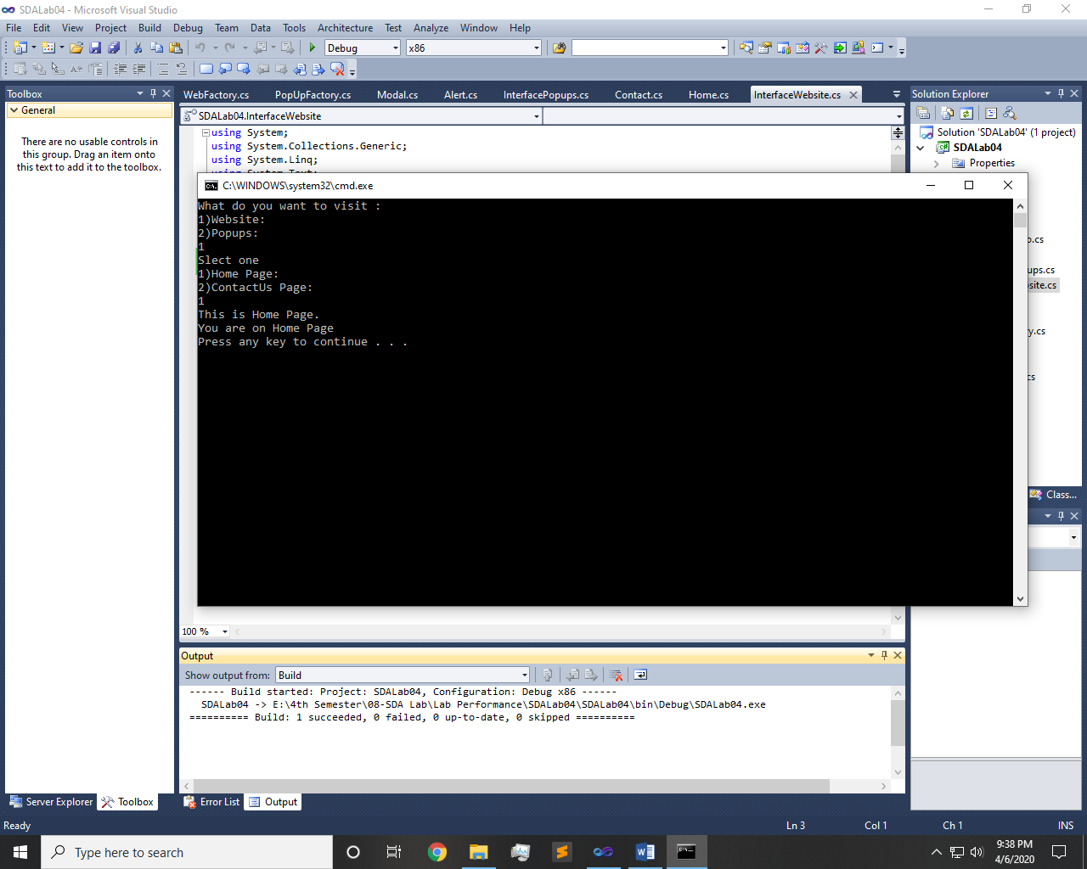 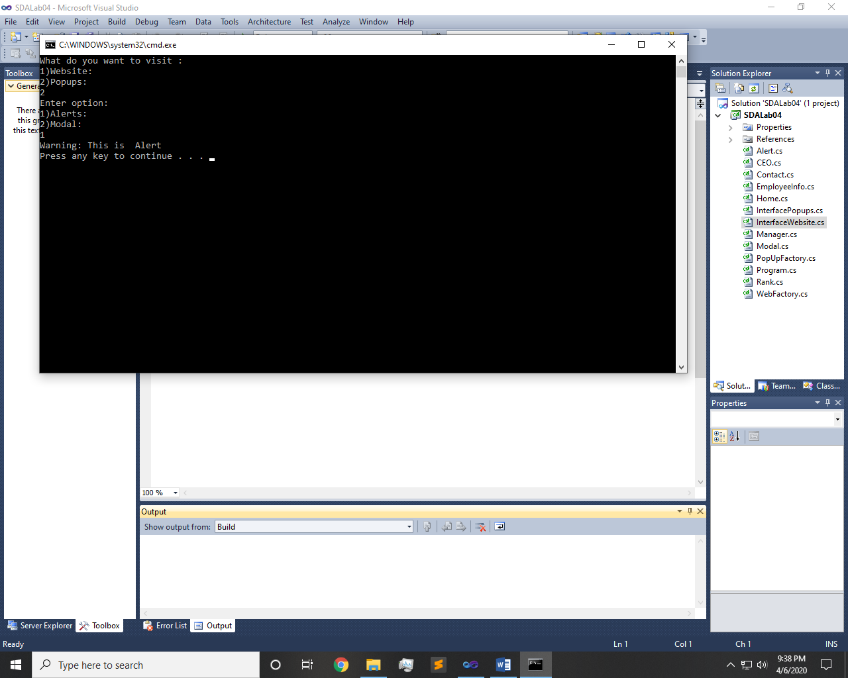

Q2: - Implement factory pattern for creating Ranks/Positions of employees

Code:-

Main:-

static void Main(string[] args)

{

Console.WriteLine("Select One: \n1)Manager: \n2)CEO:");

String opt4 = Console.ReadLine();

EmployeeInfo info = new EmployeeInfo();

Rank rank = info.getInfo(opt4);

rank.salary();

Console.WriteLine("Employee ID: {0}", rank.emp_id);

Console.WriteLine("Emplpyee Name: {0}", rank.emp_name);

Console.WriteLine("Employee Identity No. {0}", rank.emp_CNIC);

Console.WriteLine("Employee Age: {0}", rank.emp_age);

Console.WriteLine("Employee Salary: {0}", rank.salary());

}

Classes:

CEO:-

class CEO:Rank

{

public String emp_name

{

get { return "CEO "; }

}

public int emp_id

{

get { return 2; }

}

public int emp_age

{

get { return 25; }

}

public String emp_CNIC

{

get { return "2222-3311-2002"; }

}

public double salary()

{

return 584000;

}

}

Manager:-

class Manager:Rank

{

public String emp_name {

get { return "MR XYZ"; }

}

public int emp_id

{

get { return 1; }

}

public String emp_CNIC

{

get { return "75432-9876543-2"; }

}

public int emp_age {

get { return 20; }

}

public double salary()

{

return 2000;

}

}

EmployeeInfo:-

class EmployeeInfo:Manager

{

public Rank getInfo(String getinfo)

{

if (getinfo == "1")

{

return new Manager();

}

else if (getinfo == "2")

{

return new CEO();

}

else

{

return null;

}

}

}

Rank:-

interface Rank

{

String emp_name { get; }

int emp_age { get; }

double salary();

int emp_id { get; }

String emp_CNIC { get; }

}

Output:-

